Special Education
Name
Institutional Affiliation
Course
Instructor
Date

Special Education
Special education is the kind of education offered to people with disabilities. These are the individuals with some unique needs. With the education, it's confirmed that the group also have their rights which should be granted to them. Special education services should be provided and the custodians of such people should be trained on how to handle and treat them. Special educations intend to give the people an equal right as dictated by the law and this makes the group also utilize public resources effectively. Education should be offered in the least restrictive environments meaning that they should interact freely with the rest of the society. Special education includes assistive technology, related services, supplementary help and services, testing accommodations, transition services, and alternate assessment, and modified promotion.

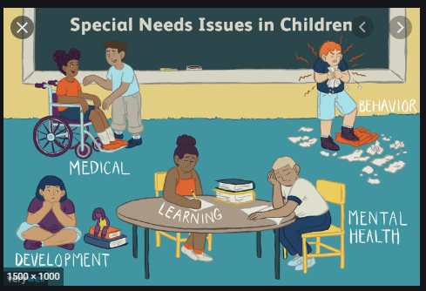

Is Education a Fundamental Right?
Although the 1787 constitution did not mention anything on the right to education, education is to be encouraged extensively. The article gives a story that illustrates the importance of education although some professionals support that it depends on who is receiving the education. Illiteracy is said to be an enduring disability. The failure of educating someone means that there is a denial of equal protection clause. For example, Plyer was for the detained children at the American Mexico border to receive education even as they continue to be detained. A law professor called the driver and many others like professor Michael from Houston University were against plyer’s ideas and termed him as insignificant, “No Undocumented child left behind”,2012. Others argued that the state would spend a lot of money to educate them and they would help very little in the economy as the undocumented children have also to be fed and clothed (Camminga, 2020). Brennan in his document wrote that education was never a constitutional right as the government never benefited.

References
Camminga, B. (2020). Disregard and danger: Chimamanda Ngozi Adichie and the voices of trans (and cis) African feminists. The Sociological Review, 68(4), 817-833.

